SIMATS ENGINEERING
SAVEETHA INSTITUTE OF MEDICAL AND TECHNICAL SCIENCES
CHENNAI – 602105

Department of Computer Science and Engineering

ASSESSMENT TOOL 2 – DEIGN AND CONNECTIVITY

Course Code: | DSA0502 | Course Title: | Query Processing for Data  Science With Real Time  Applications
CO  Assessed: | CO2 | Assessment: | Tool 1 – DEIGN AND CONNECTIVITY
Weightage: |  | Total Marks: | 40 Marks
CO2 Statement: Use Python basics and SQL libraries to connect to databases SQLite, MySQL, PostgreSQL and perform CRUD operations like Create, Read, Update, Delete. (BTL6)
Student Name: | R SAITEJA | Reg. No.: | 192424352
Section / Batch: | AIDS | Date of  Submission: | 31/07/2026
Faculty Incharge: | Dr. B.SHYAMALA GOWRI | Project Mode: | Individual Submission

Code of Conduct

I R SAITEJA(192424352) (Name / Reg No) certify that this submission is my original work and that I have adhered to all guidelines specified for this assessment. I understand that any violation of academic integrity rules will result in disciplinary action.

Signature: _________________________

Requirement  Analysis  (5 Marks) | ER Diagram  Design  (10 Marks) | Table Design &  Normalization  (5 Marks) | Database Connectivity using Python  (20 Marks) | CRUD  Operations  (5 Marks) | Total  (35 Marks)

Scenario 2: Hospital Patient Record Management System
A multi-specialty hospital receives thousands of patients every month. Currently, patient records are maintained manually, making it difficult to track patient history, doctor consultations, prescriptions, laboratory tests, and billing information. The hospital management wants a database-driven application that can store patient details, doctor information, appointments, treatment records, and payment details. Each patient may visit multiple doctors over time, and doctors may consult many patients. Laboratory tests and prescriptions must also be linked to patient records. The system should provide quick access to patient histories and generate reports on disease trends and doctor workloads. Design a relational database schema for this system and use Python SQL libraries to connect to the database and manage patient information efficiently.
Python code: import sqlite3

# ----------------------------------------
# Connect to SQLite Database
# ----------------------------------------

conn = sqlite3.connect("HospitalDB.db") cursor = conn.cursor()

print("Connected to SQLite Database")

# ----------------------------------------
# Create Tables
# ----------------------------------------

cursor.execute("""
CREATE TABLE IF NOT EXISTS Patients( patient_id INTEGER PRIMARY KEY AUTOINCREMENT,
first_name TEXT, last_name TEXT, gender TEXT, dob TEXT, phone TEXT, address TEXT, blood_group TEXT
)
""")

cursor.execute("""
CREATE TABLE IF NOT EXISTS Doctors( doctor_id INTEGER PRIMARY KEY AUTOINCREMENT, doctor_name TEXT, specialization TEXT, phone TEXT, email TEXT
)
""")

cursor.execute("""
CREATE TABLE IF NOT EXISTS Appointments( appointment_id INTEGER PRIMARY KEY AUTOINCREMENT, patient_id INTEGER, doctor_id INTEGER, appointment_date TEXT, appointment_time TEXT, status TEXT,
FOREIGN KEY(patient_id) REFERENCES Patients(patient_id),
FOREIGN KEY(doctor_id) REFERENCES Doctors(doctor_id)
)
""")

cursor.execute("""
CREATE TABLE IF NOT EXISTS Treatments( treatment_id INTEGER PRIMARY KEY AUTOINCREMENT, appointment_id INTEGER, diagnosis TEXT, treatment_details TEXT,
FOREIGN KEY(appointment_id) REFERENCES Appointments(appointment_id)
)
""")

cursor.execute("""
CREATE TABLE IF NOT EXISTS Prescriptions( prescription_id INTEGER PRIMARY KEY AUTOINCREMENT, treatment_id INTEGER, medicine_name TEXT, dosage TEXT, duration TEXT,
FOREIGN KEY(treatment_id) REFERENCES Treatments(treatment_id)
)
""")

cursor.execute("""
CREATE TABLE IF NOT EXISTS LaboratoryTests( test_id INTEGER PRIMARY KEY AUTOINCREMENT, appointment_id INTEGER, test_name TEXT, test_result TEXT, test_date TEXT,
FOREIGN KEY(appointment_id) REFERENCES Appointments(appointment_id)
)
""")

cursor.execute("""
CREATE TABLE IF NOT EXISTS Billing( bill_id INTEGER PRIMARY KEY AUTOINCREMENT, appointment_id INTEGER, amount REAL, payment_method TEXT, payment_status TEXT,
FOREIGN KEY(appointment_id) REFERENCES Appointments(appointment_id)
)
""")

conn.commit()

print("Tables Created Successfully")

# ----------------------------------------
# Insert Sample Data
# ----------------------------------------

cursor.execute("""
INSERT INTO Patients
(first_name,last_name,gender,dob,phone,address,blood_group)
VALUES
('John','David','Male','1998-05-12','9876543210','Chennai','O+')
""")

cursor.execute("""
INSERT INTO Patients
(first_name,last_name,gender,dob,phone,address,blood_group)
VALUES
('Priya','Sharma','Female','2000-08-15','9123456789','Hyderabad','A+')
""")

cursor.execute("""
INSERT INTO Doctors
(doctor_name,specialization,phone,email)
VALUES
('Dr. Kumar','Cardiology','9871111111','kumar@gmail.com')
""")

cursor.execute("""
INSERT INTO Doctors
(doctor_name,specialization,phone,email)
VALUES
('Dr. Meena','Neurology','9882222222','meena@gmail.com')
""")

cursor.execute("""
INSERT INTO Appointments
(patient_id,doctor_id,appointment_date,appointment_time,status)
VALUES
(1,1,'2026-07-31','10:30','Completed')
""")

cursor.execute("""
INSERT INTO Appointments
(patient_id,doctor_id,appointment_date,appointment_time,status)
VALUES
(2,2,'2026-07-31','11:30','Completed')
""")

cursor.execute("""
INSERT INTO Treatments
(appointment_id,diagnosis,treatment_details)
VALUES
(1,'Hypertension','Medication Prescribed')
""")

cursor.execute("""
INSERT INTO Treatments
(appointment_id,diagnosis,treatment_details)
VALUES
(2,'Migraine','Painkiller and Rest')
""")

cursor.execute("""
INSERT INTO Prescriptions
(treatment_id,medicine_name,dosage,duration)
VALUES
(1,'Amlodipine','5 mg','30 Days')
""")

cursor.execute("""
INSERT INTO Prescriptions
(treatment_id,medicine_name,dosage,duration)
VALUES
(2,'Paracetamol','500 mg','5 Days')
""")

cursor.execute("""
INSERT INTO LaboratoryTests
(appointment_id,test_name,test_result,test_date)
VALUES
(1,'Blood Pressure','140/90','2026-07-31')
""")
cursor.execute("""
INSERT INTO LaboratoryTests
(appointment_id,test_name,test_result,test_date)
VALUES
(2,'MRI Scan','Normal','2026-07-31')
""")

cursor.execute("""
INSERT INTO Billing
(appointment_id,amount,payment_method,payment_status)
VALUES
(1,2500,'UPI','Paid')
""")

cursor.execute("""
INSERT INTO Billing
(appointment_id,amount,payment_method,payment_status)
VALUES
(2,3500,'Cash','Paid')
""")

conn.commit()

print("Sample Data Inserted Successfully")

# ----------------------------------------
# Display Patients
# ----------------------------------------

print("\n========== PATIENTS ==========")

cursor.execute("SELECT * FROM Patients")
for row in cursor.fetchall():
print(row)

# ----------------------------------------
# Update Patient
# ----------------------------------------

cursor.execute(""" UPDATE Patients
SET phone='9999999999'
WHERE patient_id=1
""")

conn.commit()

print("\nPatient Phone Updated")

# ----------------------------------------
# Patient History
# ----------------------------------------

print("\n========== PATIENT HISTORY ==========")

cursor.execute("""
SELECT
Patients.first_name,
Doctors.doctor_name,
Appointments.appointment_date,
Treatments.diagnosis,
LaboratoryTests.test_name,
LaboratoryTests.test_result,
Billing.amount
FROM Patients

JOIN Appointments
ON Patients.patient_id = Appointments.patient_id

JOIN Doctors
ON Doctors.doctor_id = Appointments.doctor_id

LEFT JOIN Treatments
ON Treatments.appointment_id = Appointments.appointment_id

LEFT JOIN LaboratoryTests
ON LaboratoryTests.appointment_id = Appointments.appointment_id

LEFT JOIN Billing
ON Billing.appointment_id = Appointments.appointment_id

WHERE Patients.patient_id = 1
""")

for row in cursor.fetchall():
print(row)

# ----------------------------------------
# Doctor Workload Report
# ----------------------------------------

print("\n========== DOCTOR WORKLOAD ==========")

cursor.execute("""
SELECT
Doctors.doctor_name,
COUNT(Appointments.appointment_id)

FROM Doctors

LEFT JOIN Appointments
ON Doctors.doctor_id = Appointments.doctor_id

GROUP BY Doctors.doctor_name
""")

for row in cursor.fetchall():
print(row)

# ----------------------------------------
# Disease Trend Report
# ----------------------------------------

print("\n========== DISEASE TRENDS ==========")

cursor.execute("""
SELECT
diagnosis,
COUNT(*)

FROM Treatments

GROUP BY diagnosis
""")

for row in cursor.fetchall():
print(row)

# ----------------------------------------
# Billing Report
# ----------------------------------------

print("\n========== BILLING REPORT ==========")

cursor.execute("""
SELECT
Patients.first_name,
Doctors.doctor_name,
Billing.amount,
Billing.payment_status

FROM Billing

JOIN Appointments
ON Billing.appointment_id = Appointments.appointment_id

JOIN Patients
ON Patients.patient_id = Appointments.patient_id

JOIN Doctors
ON Doctors.doctor_id = Appointments.doctor_id
""")

for row in cursor.fetchall():
print(row)

# ----------------------------------------
# Delete Example
# ----------------------------------------

cursor.execute("""
DELETE FROM Patients
WHERE patient_id = 2
""")

conn.commit()

print("\nPatient with ID 2 Deleted")

# ----------------------------------------
# Display Remaining Patients
# ----------------------------------------

print("\n========== REMAINING PATIENTS ==========")

cursor.execute("SELECT * FROM Patients")

for row in cursor.fetchall():
print(row)

# ----------------------------------------
# Close Database
# ----------------------------------------

conn.close()

print("\nDatabase Connection Closed Successfully") output:
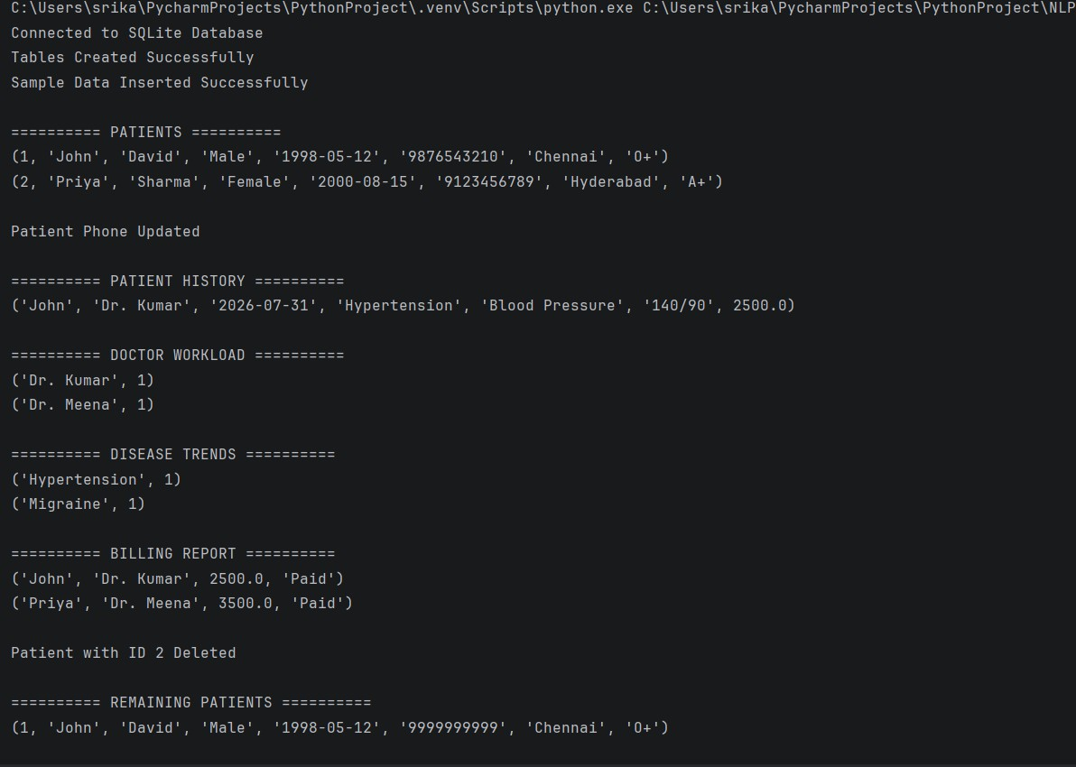

Scenario 9: Online Learning Management System
An educational technology company provides online courses to students worldwide. Students
enroll in courses, watch video lectures, submit assignments, and receive grades. Instructors create courses and manage learning materials. The platform needs a database system to maintain student profiles, instructor details, course catalogs, enrollments, assignments, and assessment results. Administrators require reports on student progress, course completion rates, and instructor performance. Design a relational database schema that supports these requirements and implement Python programs for managing enrollments and academic records.
Python code: import sqlite3

# ----------------------------------------
# Connect to SQLite Database
# ----------------------------------------

conn = sqlite3.connect("OnlineLearningDB.db") cursor = conn.cursor()

print("Connected to SQLite Database")

# ----------------------------------------
# Create Tables
# ----------------------------------------

cursor.execute("""
CREATE TABLE IF NOT EXISTS Students( student_id INTEGER PRIMARY KEY AUTOINCREMENT,
first_name TEXT, last_name TEXT, email TEXT, phone TEXT, country TEXT
)
""")

cursor.execute("""
CREATE TABLE IF NOT EXISTS Instructors( instructor_id INTEGER PRIMARY KEY AUTOINCREMENT, instructor_name TEXT, email TEXT, specialization TEXT
)
""")

cursor.execute("""
CREATE TABLE IF NOT EXISTS Courses( course_id INTEGER PRIMARY KEY AUTOINCREMENT, course_name TEXT,
category TEXT, duration TEXT, instructor_id INTEGER,
FOREIGN KEY(instructor_id) REFERENCES Instructors(instructor_id)
)
""")

cursor.execute("""
CREATE TABLE IF NOT EXISTS Enrollments( enrollment_id INTEGER PRIMARY KEY AUTOINCREMENT, student_id INTEGER, course_id INTEGER, enrollment_date TEXT, completion_status TEXT,
FOREIGN KEY(student_id) REFERENCES Students(student_id),
FOREIGN KEY(course_id) REFERENCES Courses(course_id)
)
""")

cursor.execute("""
CREATE TABLE IF NOT EXISTS Assignments( assignment_id INTEGER PRIMARY KEY AUTOINCREMENT, course_id INTEGER, assignment_title TEXT, due_date TEXT,
FOREIGN KEY(course_id) REFERENCES Courses(course_id)
)
""")

cursor.execute("""
CREATE TABLE IF NOT EXISTS Submissions( submission_id INTEGER PRIMARY KEY AUTOINCREMENT,
assignment_id INTEGER,
student_id INTEGER, submission_date TEXT, marks INTEGER, grade TEXT,
FOREIGN KEY(assignment_id) REFERENCES Assignments(assignment_id),
FOREIGN KEY(student_id) REFERENCES Students(student_id)
)
""")

cursor.execute("""
CREATE TABLE IF NOT EXISTS VideoLectures( lecture_id INTEGER PRIMARY KEY AUTOINCREMENT, course_id INTEGER, lecture_title TEXT, duration TEXT,
FOREIGN KEY(course_id) REFERENCES Courses(course_id)
)
""")

conn.commit()

print("Tables Created Successfully")

# ----------------------------------------
# Insert Sample Data
# ----------------------------------------

cursor.execute("""
INSERT INTO Students
(first_name,last_name,email,phone,country)
VALUES
('Varun','Reddy','varun@gmail.com','9876543210','India')
""")

cursor.execute("""
INSERT INTO Students
(first_name,last_name,email,phone,country)
VALUES
('Rahul','Sharma','rahul@gmail.com','9123456789','India')
""")

cursor.execute("""
INSERT INTO Instructors
(instructor_name,email,specialization)
VALUES
('Dr. Anil','anil@gmail.com','Python')
""")

cursor.execute("""
INSERT INTO Instructors
(instructor_name,email,specialization)
VALUES
('Dr. Meena','meena@gmail.com','Machine Learning')
""")

cursor.execute("""
INSERT INTO Courses
(course_name,category,duration,instructor_id)
VALUES
('Python Programming','Programming','8 Weeks',1)
""")

cursor.execute("""
INSERT INTO Courses
(course_name,category,duration,instructor_id)
VALUES
('Machine Learning','AI','10 Weeks',2)
""")

cursor.execute("""
INSERT INTO Enrollments
(student_id,course_id,enrollment_date,completion_status)
VALUES
(1,1,'2026-07-31','In Progress')
""")

cursor.execute("""
INSERT INTO Enrollments
(student_id,course_id,enrollment_date,completion_status)
VALUES
(2,2,'2026-07-31','Completed')
""")

cursor.execute("""
INSERT INTO Assignments
(course_id,assignment_title,due_date)
VALUES
(1,'Python Mini Project','2026-08-15')
""")

cursor.execute("""
INSERT INTO Assignments
(course_id,assignment_title,due_date)
VALUES
(2,'ML Classification Project','2026-08-20')
""")

cursor.execute("""
INSERT INTO Submissions (assignment_id,student_id,submission_date,marks,grade)
VALUES
(1,1,'2026-08-10',92,'A')
""")

cursor.execute("""
INSERT INTO Submissions
(assignment_id,student_id,submission_date,marks,grade)
VALUES
(2,2,'2026-08-18',88,'B+')
""")

cursor.execute("""
INSERT INTO VideoLectures
(course_id,lecture_title,duration)
VALUES
(1,'Introduction to Python','45 Minutes')
""")

cursor.execute("""
INSERT INTO VideoLectures
(course_id,lecture_title,duration)
VALUES
(2,'Introduction to Machine Learning','60 Minutes')
""")

conn.commit()

print("Sample Data Inserted Successfully")

# ----------------------------------------
# Display Students
# ---------------------------------------- print("\n========== STUDENTS ==========")

cursor.execute("SELECT * FROM Students")

for row in cursor.fetchall():
print(row)

# ----------------------------------------
# Add New Enrollment
# ----------------------------------------

cursor.execute("""
INSERT INTO Enrollments
(student_id,course_id,enrollment_date,completion_status)
VALUES
(1,2,'2026-08-01','In Progress')
""")

conn.commit()

print("\nNew Enrollment Added")

# ----------------------------------------
# Update Completion Status
# ----------------------------------------

cursor.execute("""
UPDATE Enrollments
SET completion_status='Completed'
WHERE enrollment_id=1
""")

conn.commit()

print("Enrollment Updated")

# ----------------------------------------
# Student Academic Record
# ----------------------------------------

print("\n========== STUDENT RECORD ==========")

cursor.execute("""
SELECT
Students.first_name,
Courses.course_name,
Assignments.assignment_title,
Submissions.marks,
Submissions.grade

FROM Students

JOIN Submissions
ON Students.student_id = Submissions.student_id

JOIN Assignments
ON Assignments.assignment_id = Submissions.assignment_id

JOIN Courses
ON Courses.course_id = Assignments.course_id

WHERE Students.student_id = 1
""")

for row in cursor.fetchall():
print(row)

# ----------------------------------------
# Student Progress Report
# ----------------------------------------

print("\n========== STUDENT PROGRESS ==========")

cursor.execute("""
SELECT
Students.first_name,
Courses.course_name,
Enrollments.completion_status

FROM Enrollments

JOIN Students
ON Students.student_id = Enrollments.student_id

JOIN Courses
ON Courses.course_id = Enrollments.course_id
""")

for row in cursor.fetchall():
print(row)

# ----------------------------------------
# Course Completion Report
# ----------------------------------------

print("\n========== COURSE COMPLETION ==========")

cursor.execute("""
SELECT
Courses.course_name,
COUNT(CASE WHEN Enrollments.completion_status='Completed' THEN 1 END) AS Completed_Students

FROM Courses

LEFT JOIN Enrollments
ON Courses.course_id = Enrollments.course_id

GROUP BY Courses.course_name
""")

for row in cursor.fetchall():
print(row)

# ----------------------------------------
# Instructor Performance
# ----------------------------------------

print("\n========== INSTRUCTOR PERFORMANCE ==========")

cursor.execute("""
SELECT
Instructors.instructor_name,
COUNT(Courses.course_id) AS Courses_Handled

FROM Instructors

LEFT JOIN Courses
ON Instructors.instructor_id = Courses.instructor_id

GROUP BY Instructors.instructor_name
""")

for row in cursor.fetchall():
print(row)

# ----------------------------------------
# Assignment Grades
# ----------------------------------------

print("\n========== ASSIGNMENT GRADES ==========")

cursor.execute("""
SELECT
Students.first_name,
Assignments.assignment_title,
Submissions.grade

FROM Submissions

JOIN Students
ON Students.student_id = Submissions.student_id

JOIN Assignments
ON Assignments.assignment_id = Submissions.assignment_id
""")

for row in cursor.fetchall():
print(row)

# ----------------------------------------
# Delete Enrollment Example
# ----------------------------------------

cursor.execute("""
DELETE FROM Enrollments
WHERE enrollment_id = 2
""")

conn.commit()

print("\nEnrollment Deleted")

# ----------------------------------------
# Display Remaining Enrollments
# ----------------------------------------

print("\n========== REMAINING ENROLLMENTS ==========")

cursor.execute("""
SELECT
Enrollments.enrollment_id,
Students.first_name,
Courses.course_name,
Enrollments.completion_status

FROM Enrollments

JOIN Students
ON Students.student_id = Enrollments.student_id

JOIN Courses
ON Courses.course_id = Enrollments.course_id
""")

for row in cursor.fetchall():
print(row)

# ----------------------------------------
# Close Database
# ----------------------------------------

conn.close()

print("\nDatabase Connection Closed Successfully") output:
